Jacob Howard

Signals and Systems

Lab 9

# Laplace and Matlab

**Section 1**

Solved circuit

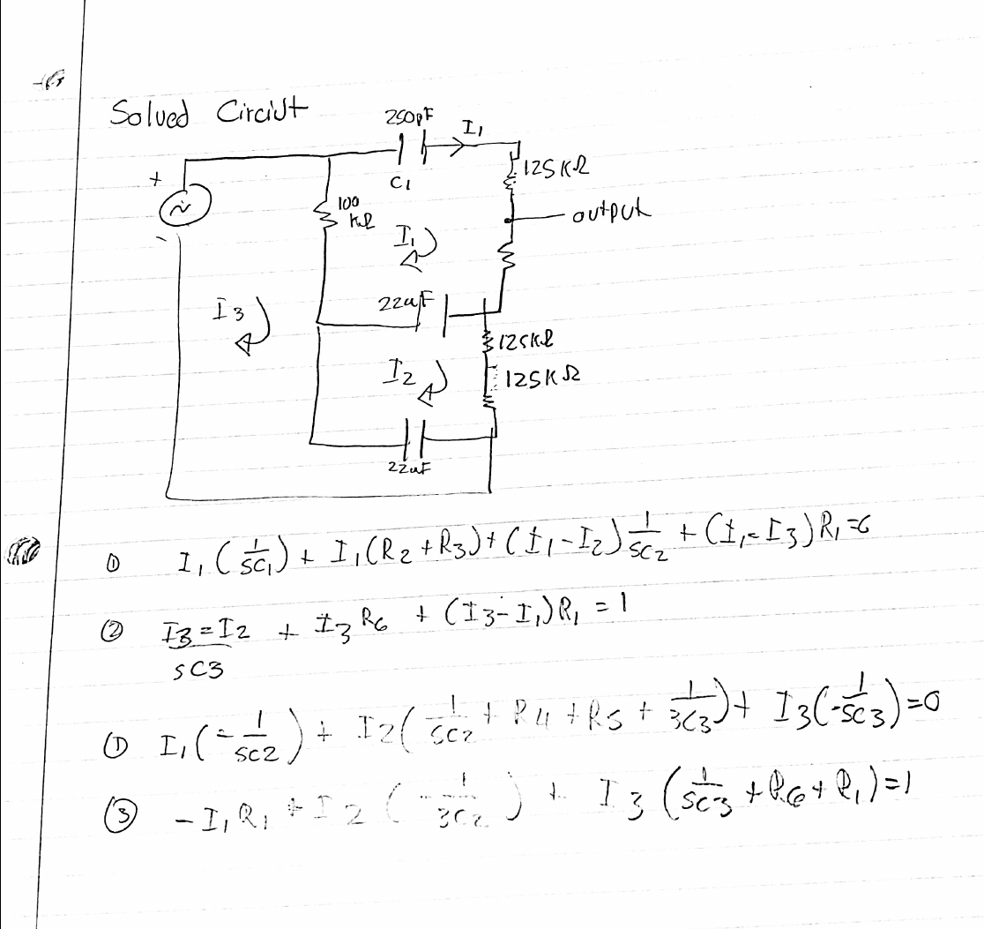

**Code**

|  |
| --- |
| A = [1/(s*C1) + R1 + R2 + R3 + 1/(s*C2) -1/(s*C2) -R1;  -1/(s*C2) 1/(s*C2) + R4 + R5 + 1/(s*C3) -1/(s*C3);  -R1 -1/(s*C3) 1/(s*C3) + R6 + R1];  V = [0; 0; 1];  I = A\V |

**Section 2**

The code for the output voltage:

|  |
| --- |
| V_out = simplify(I(1)*R3 + I(2)*(R4 + R5) + I(3)*R6); |

**Question**: Comment on how the equation was derived:

A mesh analysis was performed on the circuit to find loop currents I1, I2, and I3. The value of the

loop currents were then used to find the output voltage.

Other Code:

|  |
| --- |
| [N,D] = numden(V_out) |

**Section 3**

Code:

|  |
| --- |
| disp(vpa(N,4))  disp(vpa(D,4)) |

**Section 4**

Code:

|  |
| --- |
| Np = sym2poly(N)  Dp = sym2poly(D) |

**Section 5**

Code:

|  |
| --- |
| disp('Old Polynomial Coefficients: ')  disp('Np = ')  disp(Np)  disp('Dp =')  disp(Dp)  %find maximum value  k = max([Np,Dp]);  Np = Np/k;  Dp = Dp/k;  disp('New Polynomial Coefficients: ')  disp('Np = ')  disp(Np)  disp('Dp = ')  disp(Dp) |

**Question:** Comment on the value of Np(1). Why does it show up as zero?

Np(1) shows up as zero because the value is divided by ‘k’ which is its max value.

The values will be dampened.

**Section 6**

Code:

|  |
| --- |
| H = tf(Np,Dp)  subplot(1,3,1)  bode(H)  subplot(1,3,2)  step(H)  subplot(1,3,3)  pzmap(H) |

Plots:

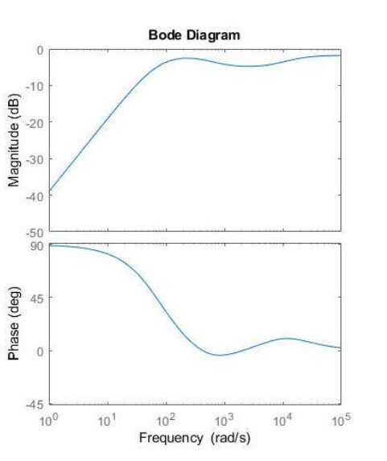

**Question**: Comment on the shape of the bode plot.

This bode plot the frequency response of the system. Magnitude

increases with increase in frequency while phase decreases with increase in frequency.

**Feedback:** I think the lab was pretty easy to follow overall. I wish we were shown or given some Matlab example codes/graph-outcomes to follow, but tother that that, the lab was fine.